Database Project
Yana Najy
Faculty No. 273222007
For My Database Project, I have decided to create a database that will store information about ticket reservations. For more complexity, I have added functionality to the Venue, procedure of reserving, and availability of the tickets.
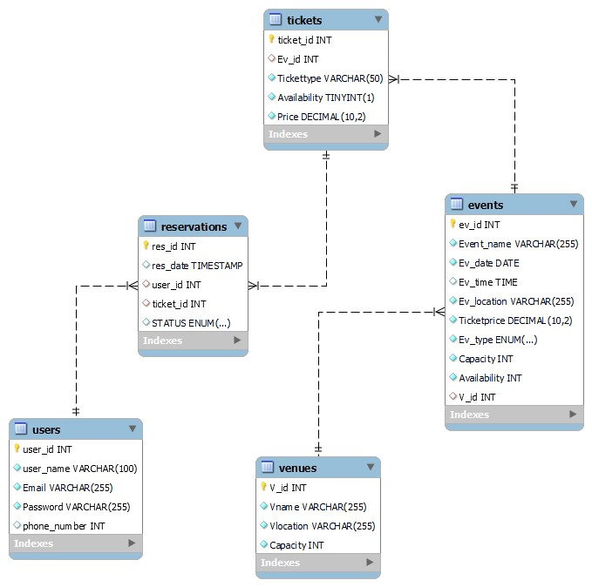
Data Structure: ( EER Diagram View)

The SQL queries were executed within a script, which is why all the queries are stored as strings.

Drop Database IF EXISTS TicketReservation;
CREATE DATABASE TicketReservation;
USE TicketReservation;

CREATE TABLE Venues (
V_id INT AUTO_INCREMENT PRIMARY KEY,
Vname VARCHAR(255) NOT NULL,
Vlocation VARCHAR(255) NOT NULL,
Capacity INT NOT NULL,
CONSTRAINT CHK_Capacity_Venues CHECK (Capacity > 0)
);
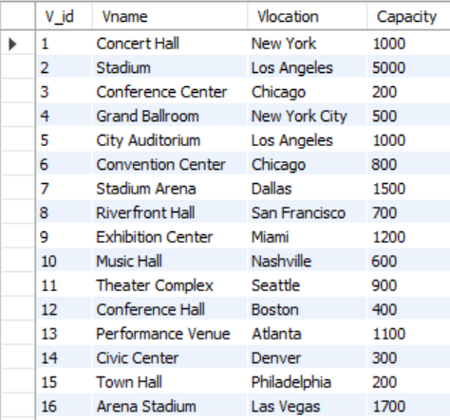

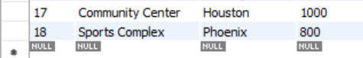

DROP TABLE IF EXISTS Events;
CREATE TABLE Events (
ev_id INT AUTO_INCREMENT PRIMARY KEY,
Event_name Varchar(255) NOT NULL,
Ev_date Date NOT NULL,
Ev_time TIME,
Ev_location Varchar(255) NOT NULL,
Ticketprice Decimal (10, 2) NOT NULL,
Ev_type ENUM('Concert', 'Sports', 'Conference', 'Theater', 'Other') NOT NULL,
Capacity INT NOT NULL,
Availability INT NOT NULL,
V_id INT,
CONSTRAINT CHK_Capacity CHECK (Capacity > 0),
CONSTRAINT CHK_Availability CHECK (Availability >= 0),
Foreign Key (V_id) References Venues(V_id)
);
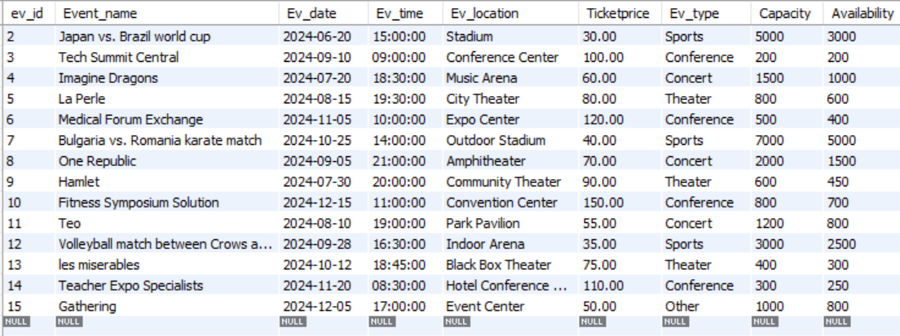
CREATE TABLE Tickets (
ticket_id INT AUTO_INCREMENT PRIMARY KEY,
Ev_id INT,
Tickettype Varchar(50) NOT NULL,
Availability Boolean NOT NULL,
Price Decimal (10, 2) NOT NULL,
Foreign Key (Ev_id) References Events(Ev_id)
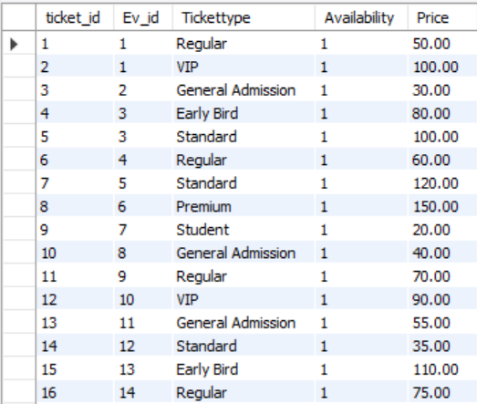
);

CREATE TABLE Users (
user_id INT AUTO_INCREMENT PRIMARY KEY,
user_name Varchar(100) NOT NULL,
Email Varchar(255) NOT NULL,
Password Varchar(255) NOT NULL,
phone_number int
);
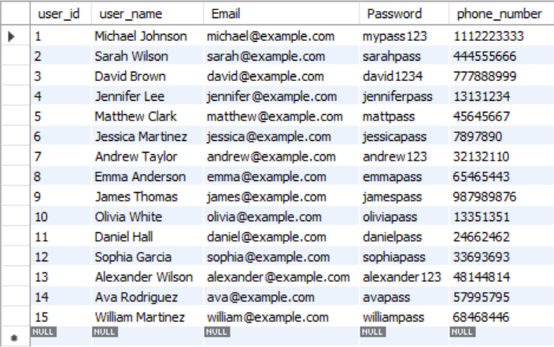

CREATE TABLE Reservations (
res_id INT AUTO_INCREMENT PRIMARY KEY,
res_date Timestamp Default current_timestamp,
user_id INT,
ticket_id INT,
STATUS ENUM ('confirmed', 'Pending', 'Canceled'),
Foreign Key (user_id) References users(user_id),
Foreign Key (ticket_id) References Tickets(ticket_id)
);
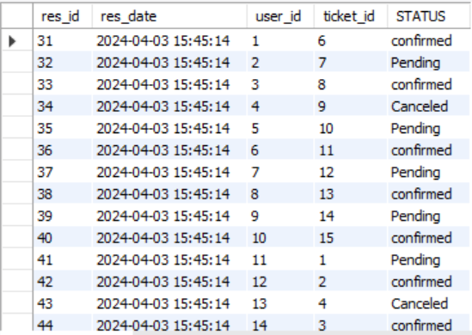

Functionality of the Database:
The MakeReservation Procedure:
- I used this procedure to check whether there are enough available tickets for specified events.
- If there are enough available tickets, it inserts a reservation into the Reservation table and updates the number of tickets available for sale. In return when there are not enough tickets or tickets are out of sale.

The ViewAvailableTickets Procedure:
- This procedure retrieves and displays available tickets for each event.

The AddVenue Procedure:
- This procedure adds a new venue to the venue table, with the details.

The ViewVenueDetails Procedure:
- It retrieves and displays details about a specific venue based on the id.

DELIMITER //
CREATE PROCEDURE MakeReservation(
IN eventId INT,
IN username VARCHAR(100),
IN numTickets INT
)
BEGIN
DECLARE availableTickets INT;
SELECT AvailableTickets INTO availableTickets FROM Events WHERE EventID = eventId;
IF availableTickets >= numTickets THEN
INSERT INTO Reservations (EventID, Username, NumTickets) VALUES (eventId, username, numTickets);

UPDATE Events SET AvailableTickets = AvailableTickets - numTickets WHERE EventID = eventId;
SELECT 'Reservation successful' AS Message;
ELSE
SELECT 'Not enough tickets available' AS Message;
END IF;
END //
DELIMITER ;

DELIMITER //
DELIMITER ;

DELIMITER //
CREATE PROCEDURE ViewAvailableTickets()
BEGIN
SELECT EventID, EventName, AvailableTickets FROM Events;
END //
DELIMITER ;

DELIMITER //
CREATE PROCEDURE AddVenue(
IN vname VARCHAR(255),
IN vlocation VARCHAR(255),
IN capacity INT
)
BEGIN
INSERT INTO Venues (Vname, Vlocation, Capacity) VALUES (vname, vlocation, capacity);
END //
DELIMITER ;

DELIMITER //
CREATE PROCEDURE ViewVenueDetails(
IN venueId INT
)
BEGIN
SELECT * FROM Venues WHERE VenueID = venueId;
END //
DELIMITER ;
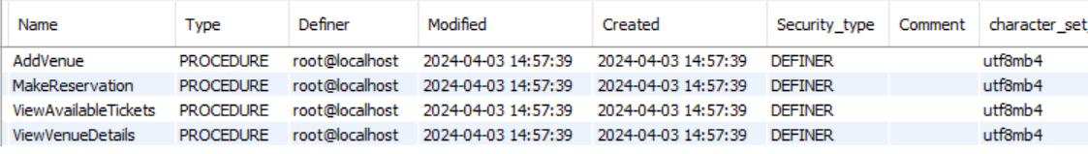
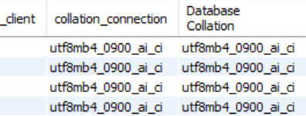

Queries:
- Displaying the ticket type and the venue location:

SELECT tickets.Tickettype, venues.Vlocation
FROM tickets
JOIN
Events ON tickets.Ev_id = events.ev_id
JOIN
venues ON Events.V_id = venues.V_id;

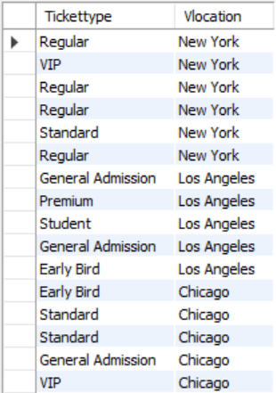

- Counting the number of reservations made by each user:

SELECT u.user_name, COUNT(r.res_id) AS num_reservations
FROM Users u
LEFT JOIN
Reservations r ON u.user_id = r.user_id
GROUP BY u.user_name;

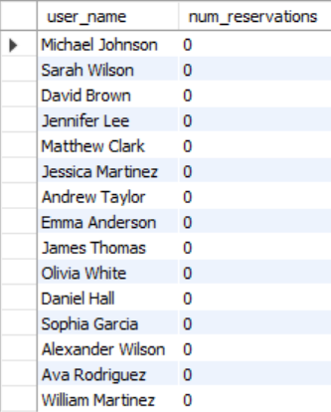

- Finding the total revenue generated from the ticket sales for each event:

SELECT e.Event_name, SUM(t.Price) AS total_revenue
FROM Events e
JOIN Tickets t ON e.ev_id = t.Ev_id
GROUP BY e.Event_name;
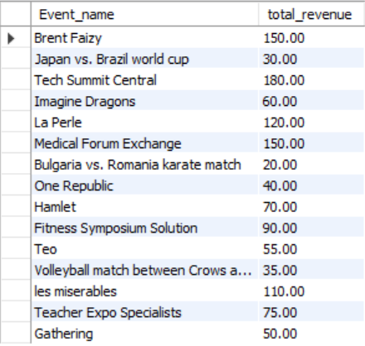

- Finding the total amount of tickets sold for each event:
SELECT e.Event_name, COUNT(r.res_id) AS total_tickets_sold
FROM Events e
LEFT JOIN Reservations r ON e.ev_id = r.ticket_id
GROUP BY e.Event_name;

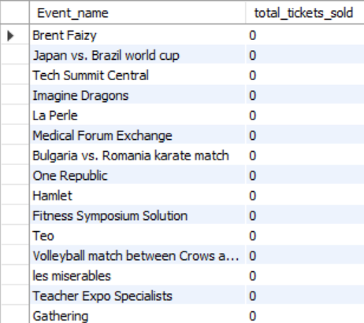

- Finding the cheapest tickets available:

SELECT e.Event_name, t.Tickettype, t.Price
FROM Events e
JOIN Tickets t ON e.ev_id = t.Ev_id
JOIN (
SELECT Ev_id, MIN(Price) AS min_price
FROM Tickets
GROUP BY Ev_id
) AS min_prices ON t.Ev_id = min_prices.Ev_id AND t.Price = min_prices.min_price;

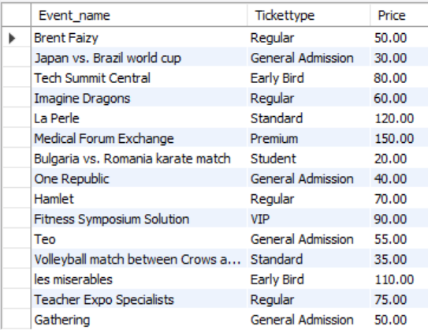

- Selecting different elements from the event location:

Select distinct Ev_location
FROM Events;

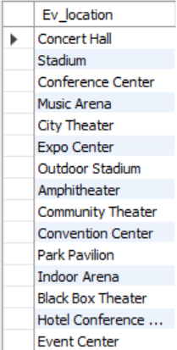

- Finding the most expansive tickets:
SELECT e.Event_name, t.Tickettype, t.Price
FROM Events e
JOIN Tickets t ON e.ev_id = t.Ev_id
JOIN (
SELECT Ev_id, MAX(Price) AS max_price
FROM Tickets
GROUP BY Ev_id
)
AS max_prices ON t.Ev_id = max_prices.Ev_id AND t.Price = max_prices.max_price;
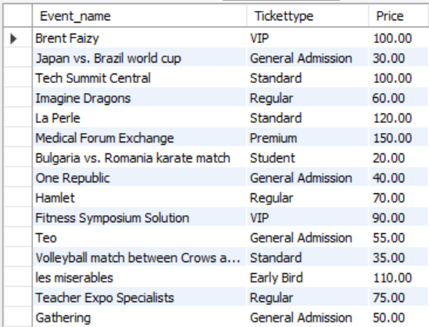

- Inserting and showing a new venue:

INSERT INTO Venues (Vname, Vlocation, Capacity)
VALUES ('Stadium', 'Vasil Levski Stadium', 15000);

SELECT * FROM Venues WHERE Vname = 'Stadium' AND Vlocation = 'Vasil Levski Stadium';

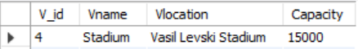

- Order the event names and venue names in order:

SELECT E.Event_name, V.Vname
FROM Events E
JOIN Venues V ON E.V_id = V.V_id
ORDER BY E.Event_name ASC, V.Vname ASC;

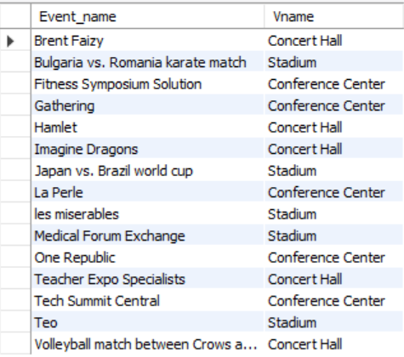

- Order the event names and venue names in order:

SELECT E.Event_name, V.Vname
FROM Events E
JOIN Venues V ON E.V_id = V.V_id
ORDER BY E.Event_name DESC, V.Vname DESC;

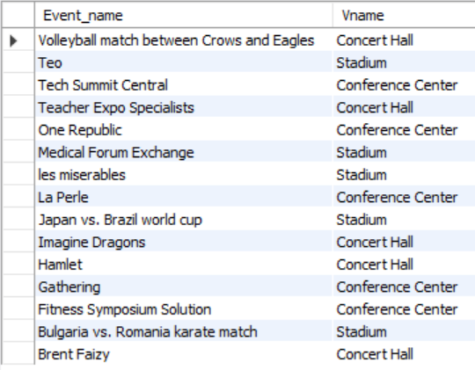

- Selecting all information about the venue ‘Stadium’ including the events:

SELECT *
FROM Venues
LEFT JOIN Events ON Venues.V_id = Events.V_id
WHERE Venues.Vname = 'Stadium';
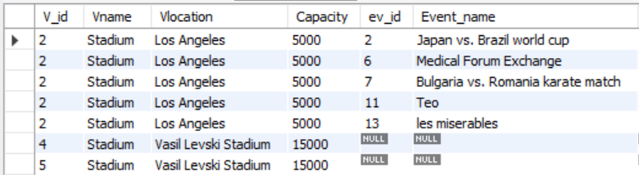
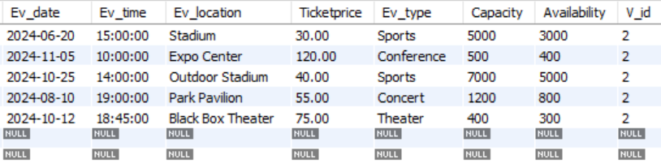

- Finding events with available tickets sorted by event date:

SELECT e.Event_name, e.Ev_date, e.Availability
FROM Events e
WHERE e.Availability > 0
ORDER BY e.Ev_date;

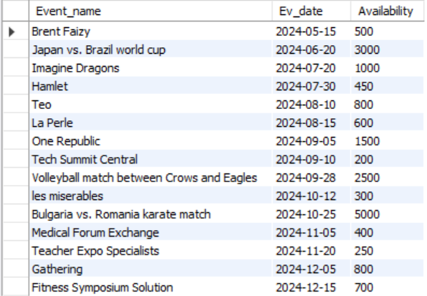

- Finding the users who made the most reservations:

SELECT u.user_name, COUNT(r.res_id) AS total_reservations
FROM Users u
LEFT JOIN Reservations r ON u.user_id = r.user_id
GROUP BY u.user_name
ORDER BY total_reservations DESC
LIMIT 1;

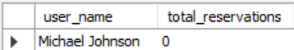

- Finding the average ticket price for each event the:

SELECT Ev_type, AVG(Price) AS AverageTicketPrice
FROM Events e
JOIN Tickets t ON e.ev_id = t.Ev_id
GROUP BY Ev_type;

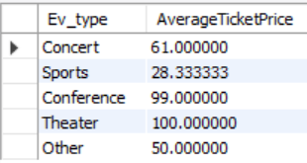

- Finding the events that have the highest ticket availability percentage:

SELECT e.ev_id, e.Event_name, (SUM(t.Availability) / e.Capacity) * 100 AS TicketAvailabilityPercentage
FROM Events e
JOIN Tickets t ON e.ev_id = t.Ev_id
GROUP BY e.ev_id, e.Event_name
ORDER BY TicketAvailabilityPercentage DESC;

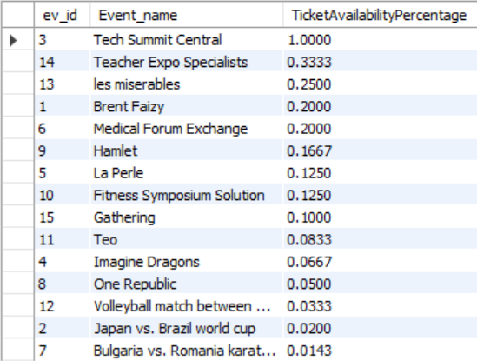

Conclusion:
A database is similar to a digital storage space where you can organize and access information efficiently. Creating, designing, and maintaining this database helped me grasp and understand how everything works. The topic I chose for my database helped me further polish the knowledge and skills acquired through the semester.

